**BANK LOAN REPORT QUARY DOCUMENT**

**BANK LOAN REPORTS SUMMARY: -**

**KPI’s:**

**Total Loan Applications**

**Select Count(id) AS Total_Loan_Applications From Bank_loan_Datas**

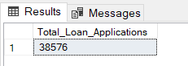

* We need to calculate the total number of loan applications received during a specified period. Additionally, it is essential to monitor the Month-to-Date (MTD) Loan Applications and track changes Month-over-Month (MoM).

**Select Count(id) AS MTD_Total_Loan_Applications From Bank_loan_Datas**

**Where MONTH(issue_date) = 12 AND YEAR(issue_date) = 2021**

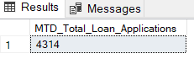

**Select Count(id) AS PMTD_Total_Loan_Applications From Bank_loan_Datas**

**Where MONTH(issue_date) = 11 AND YEAR(issue_date) = 2021**

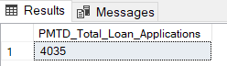

**Total Funded Amount**

**Select SUM(Loan_Amount) As Total_Funded_Amount From Bank_loan_Datas**

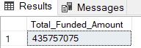

* Understanding the total amount of funds disbursed as loans is crucial. We also want to keep an eye on the MTD Total Funded Amount and analyse the Month-over-Month (MoM) changes in this metric.

**Select SUM(Loan_Amount) As MTD_Total_Funded_Amount From Bank_loan_Datas**

**Where MONTH(Issue_Date) = 12 AND YEAR(Issue_Date) = 2021**

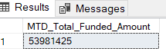

**Select SUM(Loan_Amount) As PMTD_Total_Funded_Amount From Bank_loan_Datas**

**Where MONTH(Issue_Date) = 11 AND YEAR(Issue_Date) = 2021**



**Total Amount Received**

**Select SUM(Total_Payment) AS Total_Recived_Amount From Bank_loan_Datas**

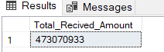

* Tracking the total amount received from borrowers is essential for assessing the bank's cash flow and loan repayment. We should analyse the Month-to-Date (MTD) Total Amount Received and observe the Month-over-Month (MoM) changes.

**Select SUM(Total_Payment) AS MTD_Total_Recived_Amount From Bank_loan_Datas**

**Where MONTH(Issue_Date) = 12 AND YEAR(Issue_Date) = 2021**

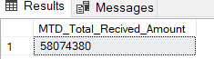

**Select SUM(Total_Payment) AS PMTD_Total_Recived_Amount From Bank_loan_Datas**

**Where MONTH(Issue_Date) = 11 AND YEAR(Issue_Date) = 2021**

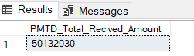

**Average Interest Rate**

**Select AVG(Int_Rate) AS Avg_Int_Rate From Bank_loan_Datas**

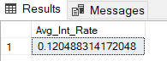

* Calculating the average interest rate across all loans, MTD, and monitoring the Month-over-Month (MoM) variations in interest rates will provide insights into our lending portfolio's overall cost.

**Select AVG(Int_Rate) AS MTD_Avg_Int_Rate From Bank_loan_Datas**

**Where MONTH(Issue_Date) = 12 AND YEAR(Issue_Date) = 2021**

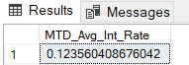

**Select AVG(Int_Rate) AS PMTD_Avg_Int_Rate From Bank_loan_Datas**

**Where MONTH(Issue_Date) = 11 AND YEAR(Issue_Date) = 2021**

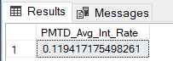

**Average Debt-to-Income Ratio (DTI)**

**Select Round(AVG(Dti),4)*100 As DTI_Avg_Ratio From Bank_loan_Datas**

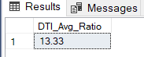

* Evaluating the average DTI (Debt to income ratio) for our borrowers helps us gauge their financial health. We need to compute the average DTI for all loans, MTD, and track Month-over-Month (MoM) fluctuations.

**Select Round(AVG(Dti),4)*100 As MTD_DTI_Avg_Ratio From Bank_loan_Datas**

**Where MONTH(Issue_date) = 12 AND YEAR(Issue_Date) = 2021**

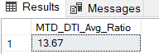

**Select Round(AVG(Dti),4)*100 As PMTD_DTI_Avg_Ratio From Bank_loan_Datas**

**Where MONTH(Issue_date) = 11 AND YEAR(Issue_Date) = 2021**

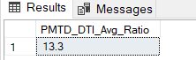

**Good Loan v Bad Loan KPI’s:**

**Good Loan Application Percentage**

**Select**

**(Count**

**(CASE**

**WHEN Loan_Status = 'Fully Paid' OR Loan_Status = 'Current'**

**THEN ID**

**END)*100)**

**/**

**COUNT(id) As Good_Loan_Persentage**

**From Bank_loan_Datas**

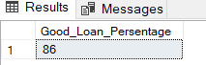

**Good Loan Applications**

**Select COUNT(Id) As Good_Loan_Applications from Bank_loan_Datas**

**Where Loan_Status in ('Fully Paid','Current')**

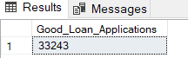

**Good Loan Funded Amount**

**Select SUM(Loan_Amount) As Good_Loan_Fund_Amount from Bank_loan_Datas**

**Where Loan_Status in ('Fully Paid','Current')**

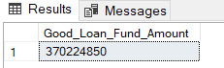

**Good Loan Total Received Amount**

**Select SUM(Total_Payment) As Good_Loan_Recived_Amount from Bank_loan_Datas**

**Where Loan_Status in ('Fully Paid','Current')**

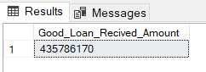

Select

**Bad Loan Application Percentage**

**Select**

**(Count**

**(CASE**

**WHEN Loan_Status = 'Charged Off'**

**THEN ID**

**END)*100)**

**/**

**COUNT(id) As Bad_Loan_Persentage**

**From Bank_loan_Datas**

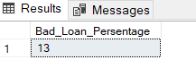

**Bad Loan Applications**

**Select COUNT(Id) As Bad_Loan_Applications from Bank_loan_Datas**

**Where Loan_Status = 'Charged Off'**

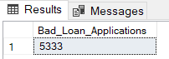

**Bad Loan Funded Amount**

**Select SUM(Loan_Amount) As Bad_Loan_Fund_Amount from Bank_loan_Datas**

**Where Loan_Status = 'Charged Off'**

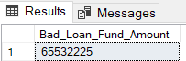

**Bad Loan Total Received Amount**

**Select SUM(Total_Payment) As Bad_Loan_Recived_Amount from Bank_loan_Datas**

**Where Loan_Status = 'Charged Off'**

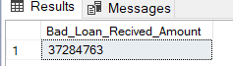

**Loan Status Grid View:**

**Select**

**Loan_Status,**

**COUNT(id) AS Loan_Count,**

**SUM(total_Payment) AS Total_Amount_Recived,**

**SUM(Loan_Amount) AS Total_Fund_Amount,**

**AVG(Int_Rate *100) AS Intrest_Rate,**

**AVG(Dti *100) AS DTI**

**FROM**

**Bank_loan_Datas**

**Group By**

**Loan_Status**

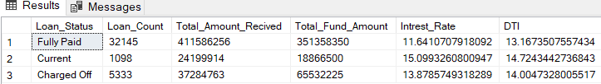

**Month to Date(MTD) Fund Amount and Received Amount**

**Select**

**Loan_Status,**

**SUM(Total_Payment) As MTD_Total_Amount_Recived,**

**SUM(Loan_Amount) As MTD_Total_Amount_Fund**

**From Bank_loan_Datas**

**Where MONTH(Issue_Date) = 12**

**Group By Loan_Status**

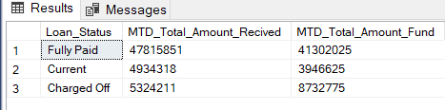

**Monthly Trends by Issue Date**

**Select**

**MONTH(Issue_Date) AS Month_Number,**

**DATENAME(Month, Issue_Date) AS MONTH,**

**COUNT(Id) AS Total_Loan_Applications,**

**SUM(Loan_Amount) AS Total_Fund_Amount,**

**SUM(Total_Payment) As Total_Recived_Amount**

**From Bank_loan_Datas**

**Group By MONTH(Issue_Date) , DATENAME(Month, Issue_Date)**

**Order By Month_Number**

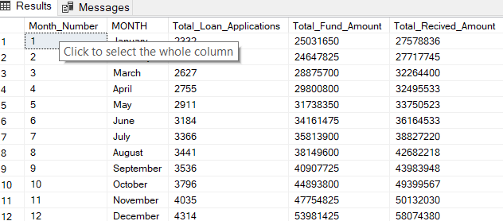

**Regional Analysis by State**

**Select**

**Address_State,**

**COUNT(Id) AS Total_Loan_Applications,**

**SUM(Loan_Amount) AS Total_Fund_Amount,**

**SUM(Total_Payment) As Total_Recived_Amount**

**From Bank_loan_Datas**

**Group By Address_State**

**Order By Address_State DESC**

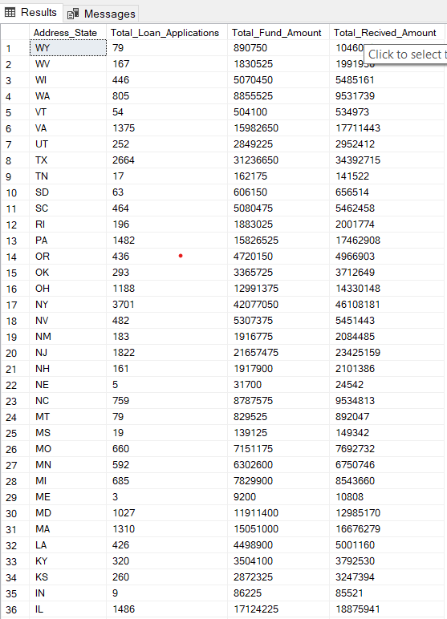

**Loan Term Analysis**

**Select**

**Term,**

**COUNT(Id) AS Total_Loan_Applications,**

**SUM(Loan_Amount) AS Total_Fund_Amount,**

**SUM(Total_Payment) As Total_Recived_Amount**

**From Bank_loan_Datas**

**Group By Term**

**Order By Term**

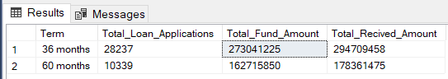

**Employee Length Analysis**

**Select**

**Emp_Length,**

**COUNT(Id) AS Total_Loan_Applications,**

**SUM(Loan_Amount) AS Total_Fund_Amount,**

**SUM(Total_Payment) As Total_Recived_Amount**

**From Bank_loan_Datas**

**Group By Emp_Length**

**Order By Emp_Length**

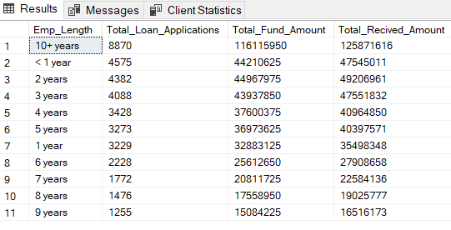

**Loan Purpose Breakdown**

**Select**

**Purpose,**

**COUNT(Id) AS Total_Loan_Applications,**

**SUM(Loan_Amount) AS Total_Fund_Amount,**

**SUM(Total_Payment) As Total_Recived_Amount**

**From Bank_loan_Datas**

**Group By Purpose**

**Order By Total_Fund_Amount DESC**

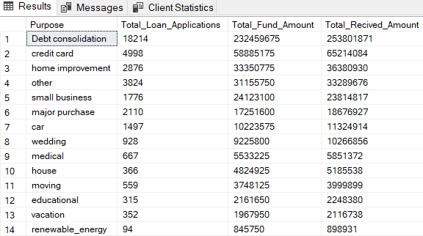

**Home Ownership Analysis**

**Select**

**Home_Ownership,**

**COUNT(Id) AS Total_Loan_Applications,**

**SUM(Loan_Amount) AS Total_Fund_Amount,**

**SUM(Total_Payment) As Total_Recived_Amount**

**From Bank_loan_Datas**

**Group By Home_Ownership**

**Order By Total_Fund_Amount DESC**

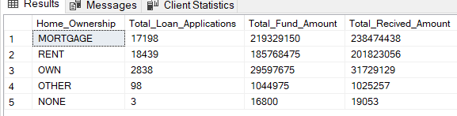

*Note: We have applied multiple Filters on all the dashboards. You can check the results for the filters as well by modifying the query and comparing the results. For e.g.*

*See the results when we hit the Grade A in the filters for dashboards.*

***SELECT***

***purpose AS PURPOSE,***

***COUNT(id) AS Total_Loan_Applications,***

***SUM(loan_amount) AS Total_Funded_Amount,***

***SUM(total_payment) AS Total_Amount_Received***

***FROM bank_loan_data***

***WHERE grade = 'A'***

***GROUP BY purpose***

***ORDER BY purpose***